

Sri Lanka Institute of Information Technology

**Design Document for Procurement System**

**Case Studies for Software Engineering**

**Assignment 01**

Submitted by: CSSE_WE_6

Submitted to:

**Mr Udara Samarathunge**

(Senior Lecturer - Department of Software Engineering)

Faculty of Computing

28/07/2019



# **Member Details**

|  |  |
| --- | --- |
| Name | IT Number |
| M.A.Ashar Ahamed | IT17043588 |
| P.P.G.S.H.A.Guruge | IT17042352 |
| Ranawake P. I | IT16097520 |
| Wellala S. S | IT17009096 |

**Table of Contents**

Member Details **1**

**Introduction** **3**

Use Case Diagram **4**

Assumptions and Terms used in Use Cases 5

Assumptions 5

Terms 5

Use Case Scenarios **7**

**Class Diagram** **16**

**Sequence Diagram** **17**

**Low fidelity User Interaction Diagrams** **20**

Create Purchase Requisition Page 20

View Purchase Requisitions Page 21

Approve Purchase Requisition Page 22

Receive Orders Page 23

View Purchase Requisitions UI for Mobile application 24

Receive Orders UI for Mobile Application 25

**High fidelity User Interaction Diagrams** **26**

Login page for mobile application 26

Login page for web application 26

Approve Purchase Requisition for Mobile Application 27

Create Purchase Requisition for Mobile Application 28

# **Introduction**

Material procurement process is at the heart of construction industry due to many reasons. Even though it looks like a simple and straightforward process, when mismanaged, material procurement can seriously affect the profit margin, product quality, labour utilization and result in a failure of the project. The factors such as limited storage due to the highly dynamic nature of the construction sites, highly distributed construction sites, contract based labour, tightly scheduled construction goals make the necessity for a well defined construction process at utmost importance in construction industry.

The design presented in this document is for a distributed procurement system to minimize the procurement errors by providing means of well defined interfaces with proper functionality to the relevant stakeholders. The simple flow of the system would be, when a site manager makes an order, a chief procurement officer would approve the order by which time the finance staff will make the payments and finally once the supplier delivers the goods a warehouse manager at the site would verify and accept the materials.

This system is designed to eliminate the communication issues which are common in the construction industry. The software will give convenient interfaces suitable for the job role, such as a mobile app for site and warehouse manager while a web application for finance staff. Since all users are properly authenticated and authorized, only the relevant functionality is available for a respective user, so that responsibilities and job roles are not overlapped which enables the construction process to be advanced smoothly with minimum level of conflict and communication mismatches.

This is a technical design document which consists of a use case diagram with most important scenarios, a detailed class diagram, sequence diagrams and finally low fidelity and high fidelity user interface designs as user interaction diagrams.

# **Use Case Diagram**

Google drive link to the above document:

https://drive.google.com/open?id=1ZDUl5bPGuWTaPfZb1vp0d2HNiu5po2eW

## **Assumptions and Terms used in Use Cases**

### Assumptions

### Terms

* PR – Purchase Requisition
* PO – Purchase Order
* CPO – Chief Procurement Officer
* Delivery Notice - goods that describes the goods and the quantities being delivered
* Credit Note - a receipt given by a supplier to a buyer who has returned goods, which can be offset against future purchases
* Purch Req - An order raised internally but needs approval before sending to supplier
* Purch Order - The order which is sent to the supplier
* Supplier Invoice - The total bill issued by the supplier after goods are delivered
* Supersede Authorization of a Purch Req - take the place of the authorized person to authorize a PR.
* Forward Authorization of a Purch Req - forward the authorization of a PR to someone.
* Request for Quotation (RFQ)- an RfQ is interesting when you have never purchased the products with that supplier before and therefore don't know their price.
* RfQs become unnecessary once you have established your favorite supplier for each item and will only increase the delay in the delivery of your items. In that case, the process will be simpler by starting straight from a Purchase Order
* Amending a PR -
  + You cannot change the order reference.
  + You can only change the supplier if no goods or services have been added to the order.
  + You can add, amend and delete items on an order depending on how complete the order is.
  + You cannot change any details once an order is approved
* When you amend a PO, the system creates a PO Amend (POA) document based on the existing PO Reference. Enter a reason when initiating the amendment. When the amendment is submitted, the CPO receives a notification. This is his or her notification that the order has changed
* Authorized Site Managers with special privileges can register a supplier quickly, when creating a Purchase Requisition.
* Site Manager can add only material information to the system, this does not state that the prices can added as well. Prices for materials are determined by the Accounting Staff. This approach is used because the Account Staff do not have the technical knowledge about materials that are used in the site. Therefore, material information is added by the Site Manager and their prices are managed by the Accounting Staff.

# **Use Case Scenarios**

|  |  |
| --- | --- |
| Use Case No | 1 |
| Use Case Title | Creating a Purchase Requisition |
| Primary Actor | Site Manager |
| Pre-conditions | User should be authorized to raise a PR |
| Main Success Scenario | 1. User logins into Procurement System 2. User navigates to Purchase Requisition Page 3. User clicks on the Add Button 4. User enters the Site 5. User enters the Requisitioner 6. User enters the Required Part 7. System shows available Suppliers for the required part 8. User selects a Supplier 9. User enters the required Quantity 10. System fetches the unit price of the part of the Supplier 11. System calculates the total gross amount for the order. 12. User enters the Required Date 13. User enters the Delivery Address 14. User saves the new Purchase Requisition 15. System changes the status of PR from “Created” to “Planned” 16. User releases the order 17. System raises the Order to Supplier |
| Extensions | 6a. Required Part is not available in the System    6a.1. System shows an Info message and displays a part is not available in the system.    6a.2. System shows Create Inventory Part button    6a.3. User clicks the Create Inventory Part button    6a.4. System navigates the user to Create Inventory Part Page    6a.5. User enters new Part’s details to the system    6b. Required Part needs an authorization   6b.1. System shows an info message and display an approval is needed for the entered part    6c. Required Part needs special Handling Instructions   6c.1. System shows the part needs Special Handling Instruction as an info message   6c.2. System adds handling information    7a. Supplier is not available for the entered part    7a.1. System shows an Info message and displays a supplier is not available for the part.    7a.2. System shows a Quick Supplier Registration Button    7a.3. User clicks the Button    7a.4. System checks user’s authority    7a.5. System navigates to add Supplier Page    7a.6. User enters new Supplier’s Details    10a. Fetched Unit Price by the system is outdated    10a.1. User selects Update Price Manually Option    10a.2. System checks user’s authority    10a.3. User enters new Unit Price    10a.4. System recalculates new total gross amount    14a. The total gross amount exceeds the limit of Rs.100,000.    14a.1. System changes the status of PR from “Planned” to “To be Authorized”    14a.2. System sends a notification to the Procurement Staff about the raised PR.    14b. User wants to check the available quantity for the entered part in the stock in the site    14b.1. User selects Inventory Part Availability Button    14b.2. System shows the available quantity for the part    14c. User wants to check the available storage space for the entered Site    14c.1. User selects the Storage Availability Button    14c.2. System shows the information about the storage of the warehouse and its availability    14d. User wants to add a special notice about the PR    14d.1. User select add Note button    14d.2. User enters the Note    14e. User wants to print the created PR   14e.1. User clicks Print PR button.   14e.2. System generates a PDF and prompts an email address   14e.3. User enters the email address   14e.4. System sends an email to the email address. |

|  |  |
| --- | --- |
| Use Case No | 2 |
| Use Case Title | Approving a Purchase Requisition |
| Primary Actor | Chief Procurement Officer |
| Pre-conditions | User should be authorized to approve a PR; PR should be in “To be Approved” state |
| Main Success Scenario | 1. User logins into Proc System 2. User navigates to Purchase Requisition Page 3. User clicks filters the records by Unauthorized PRs 4. System shows unauthorized PR lines 5. User selects the required PR line 6. User selects Approve Button 7. System changes the status of PR from “To be Authorized” to “Approved” 8. System generates a Purchase Order Reference 9. System raises the Purchase Order to the Supplier along with the Purchase Order Reference |
| Extensions | 5a. User wants to give the authority to approve the PR to another Procurement Staff Member.    5a.1. User clicks the Forward Authorization button.    5a.2. System displays the available Proc Staff Members    5a.3. User selects a staff member and confirms   5a.4.The system gives the authority to the new user to Manage the selected PR line.    5b. User wants to take the authority to approve the PR on behalf of another Procurement Staff Member    5b.1. User clicks the Supersede Authorization button.    5b.2. The system gives the authority to the new user to Manage the selected PR line.    5c. User wants to reject the PR    5c.1. User clicks the Reject button.    5c.2. System prompts the user enter the Reject Reason and Reject Note.    5c.3. User enters the Reject Reason and Reject Note.    5c.4. System Rejects the PR and change the status from “To be Authorized” to “Rejected”    5c.5. System sends a notification to the Site Manager who created the PR requisition.    5d. User wants to print the PR   5d.1. User clicks Print PR button.   5d.2. System generates a PDF and prompts an email address   5d.3. User enters the email address   5d.4. System sends an email to the email address.    5e. User wants to view all authorizers for the PR    5e.1. User clicks View Authorizers button    5e.2. System shows all the Authorizers from the selected PR |

|  |  |
| --- | --- |
| Use Case No | 3 |
| Use Case Title | Receive Goods from Supplier |
| Primary Actor | Warehouse Manager |
| Pre-conditions | Goods must be delivered to the site either partly or fully |
| Main Success Scenario | 1. User logins into the system 2. User navigates to the Purchase Order page 3. User finds the order by order reference (provided by the supplier) 4. User inspects the arrived goods quality and quantity against the PO 5. User navigates to the Register Arrived Goods page. 6. User finds the order by order reference (provided by the supplier) 7. User clicks Receive button. 8. System shows available location slots in the Warehouse 9. User selects a slot. 10. System allocates the new slot to the arrived goods 11. System changes the PO state from “Approved” to “Received”. 12. User feeds the invoice for the received goods to the system. 13. System forwards the invoice to the Accounting Department |
| Extensions | 4a. One or more parts have been damaged or missing during the shipment         1. User enters the quantity to be returned.         2. User enters Reject Reason         3. User enters a Reject Note         4. System deducts the by Arrived Quantity by Returned Part Quantity for the PO         5. System prints the reject report to the user.                4a.5.1. User wants to claim the returned items as credit notes                              1. User clicks generate credit note.                              2. System generates a credit note.    4b. The goods are delivered into multiple times       1. User clicks the Split button       2. System prompts the user to enter the quantity to Split       3. User enters the quantity to Split    4.System splits the quantity to be received from quantity received according to the Split Quantity     5. System creates a sub version of the Purchase Order for the quantity to split from the Original Purchase Order. |

|  |  |
| --- | --- |
| Use Case No | 4 |
| Use Case Title | Review Quotations |
| Primary Actor | Accounting Staff Member |
| Pre-Conditions | User should be properly authorized to use the system |
| Main Success Scenario | 1. User Login to the System 2. User navigates to the review quotations page 3. A list of available quotations from suppliers are loaded to the page 4. User clicks on one to view detailed quotation 5. User clicks on “Approve” button to approve the quotation 6. System prompts a window with unpriced items 7. User enters prices to the corresponding items 8. User clicks confirm button 9. System sends a notification to the supplier of the approval of his/her quotation |
| Extensions | 5.a.   User hard rejects the quotation  5.a.1.   User clicks on the “Hard Reject” button  5.a.2.   System prompts a window to type in the rejection reason  5.a.3.   User types the rejection reason  5.a.4.   User clicks on the “Confirm” button  5.a.5.   System sends a note to the supplier with the rejection reason  5.a.6.   System prompts a list of alternative suppliers to send the quotation again  5.a.7.   User selects one or more suppliers  5.a.8.   User clicks on the “Send” button  5.a.9.   System sends the quotation to the selected suppliers and remove the quotation from the rejected supplier and return back to the main listing of quotations  5.a.7.1.   User clicks on the cancel button  5.a.7.2.   System remove the quotation from the rejected  Supplier and return back to the main listing of  Quotations  5.b.   User soft rejects the quotation (In cases such as some prices are acceptable, and some needs a reconsideration)  5.b.1.   User clicks on the “Soft Reject” button  5.b.2.   System prompts a window to type in the rejection reason  5.b.3 User clicks on the ‘Submit’ button  5.b.4 System send the quotation revision request to the supplier |

# **Class Diagram**

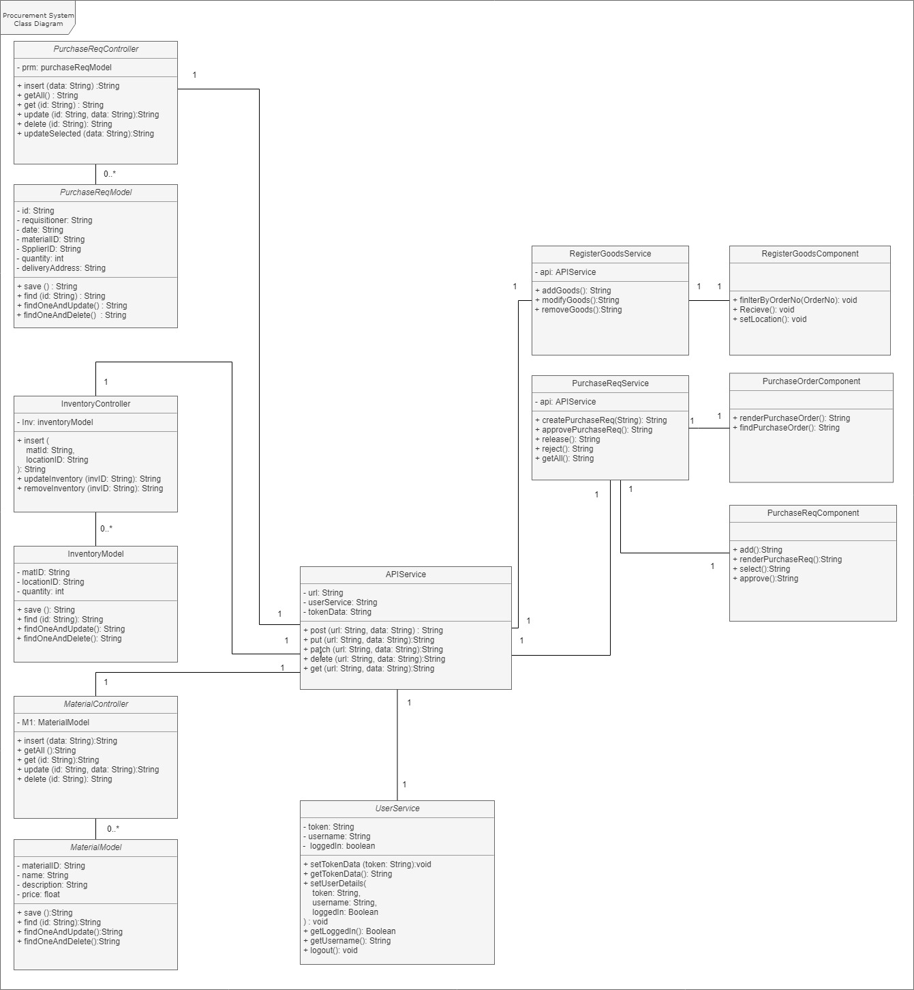

# **Sequence Diagram**

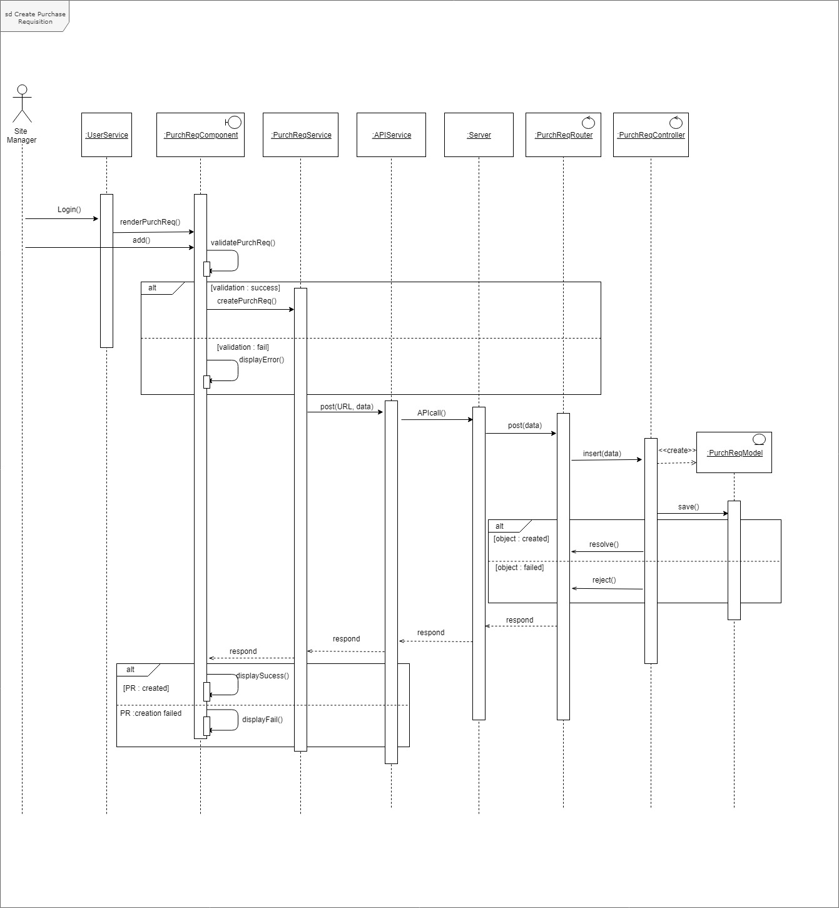

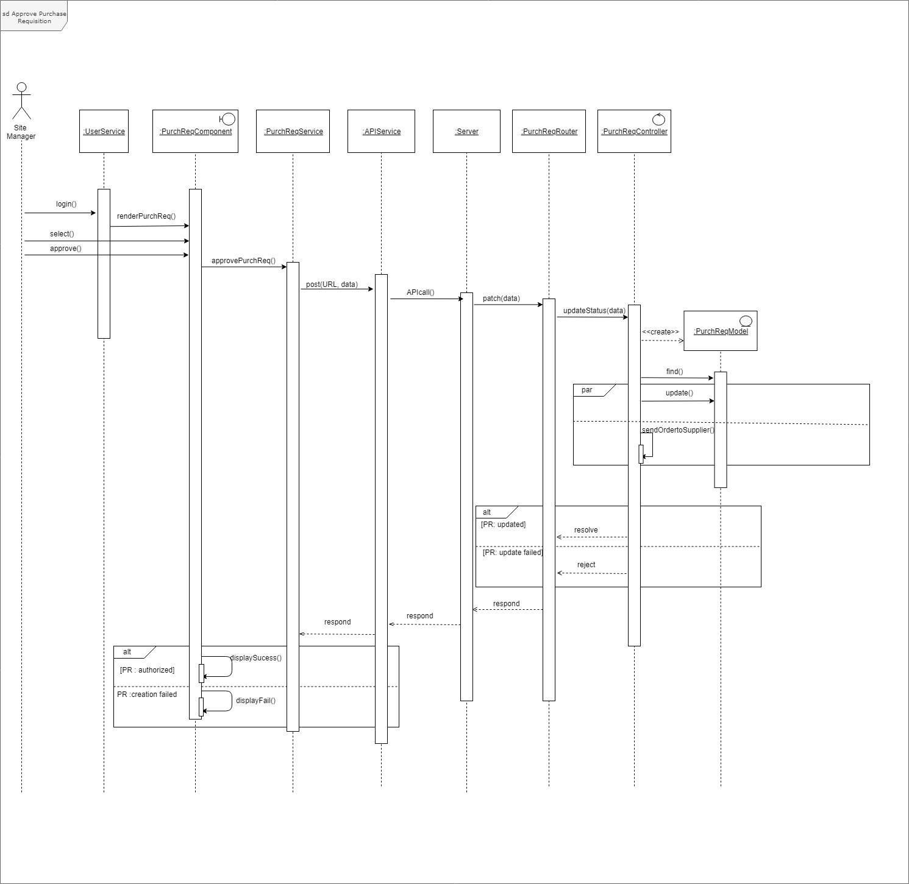

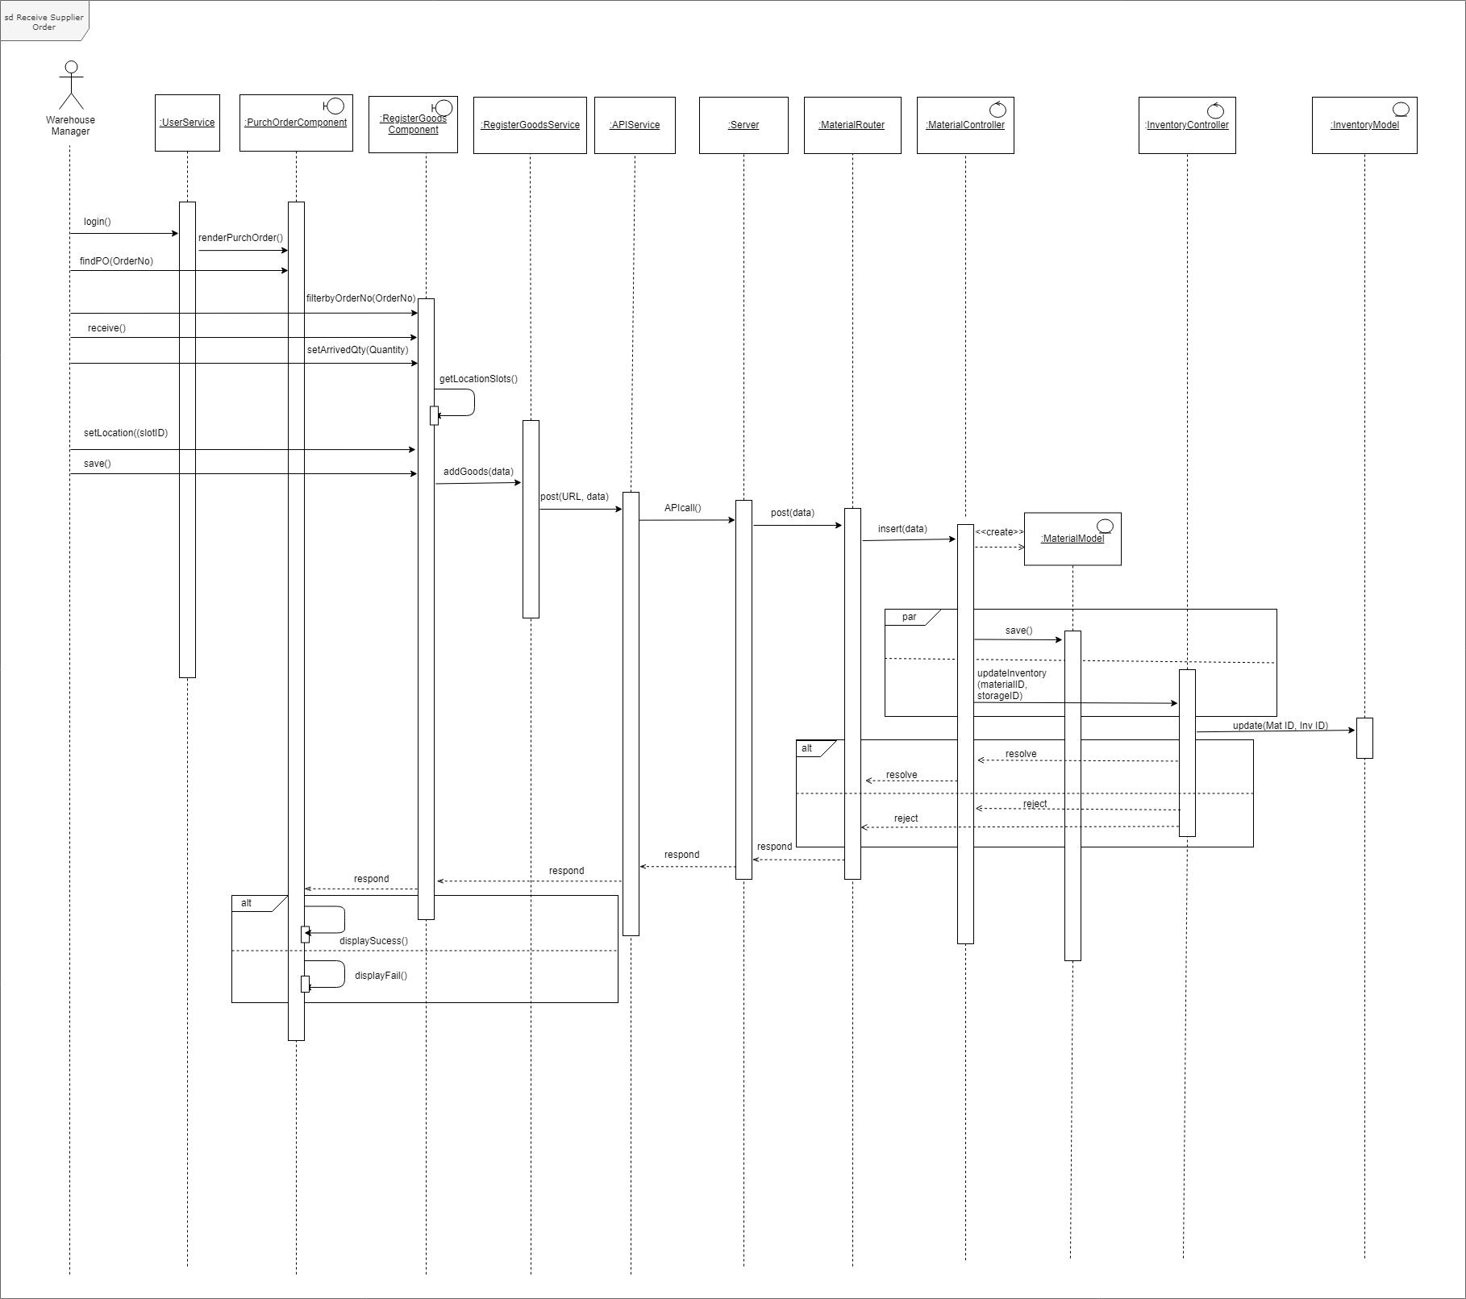

# **Low fidelity User Interaction Diagrams**

## Create Purchase Requisition Page

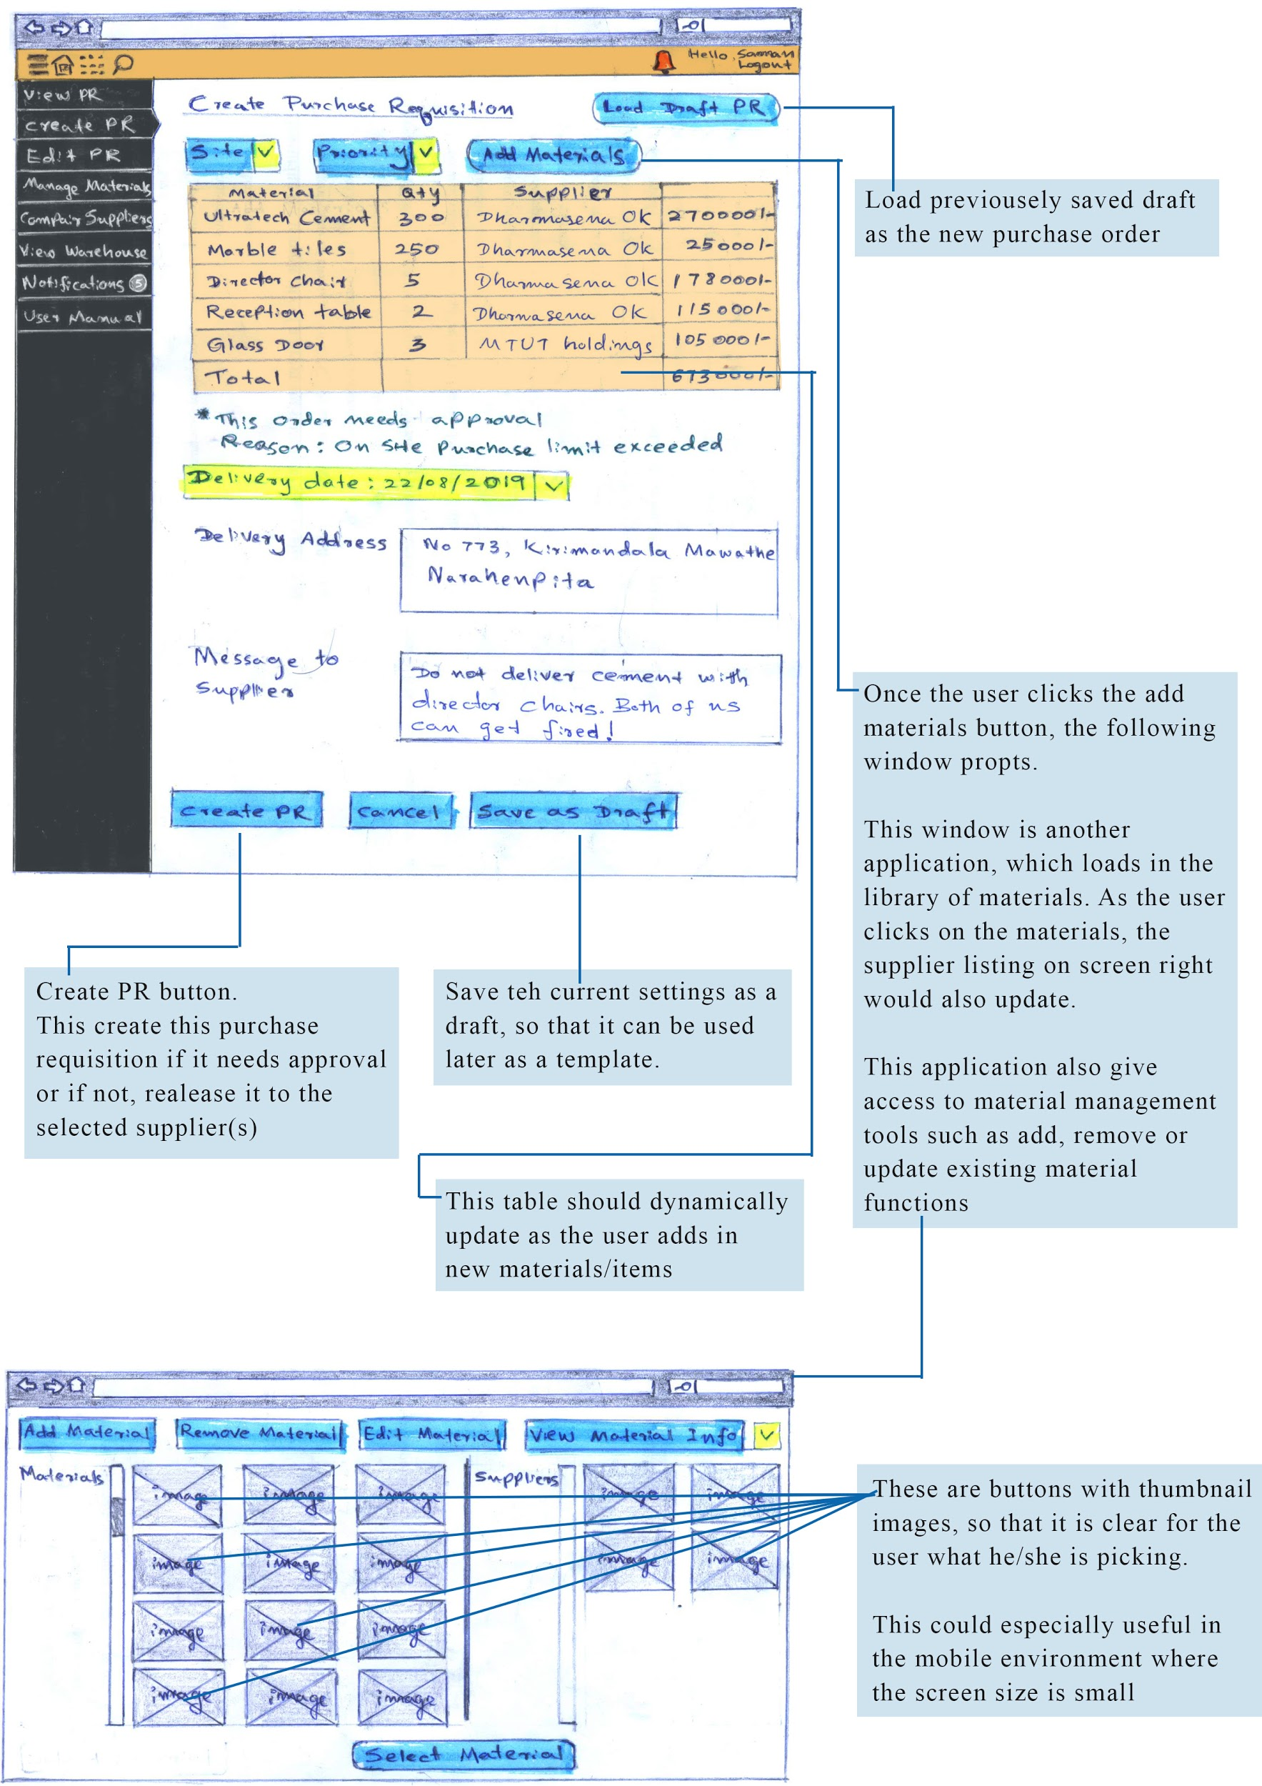

## View Purchase Requisitions Page

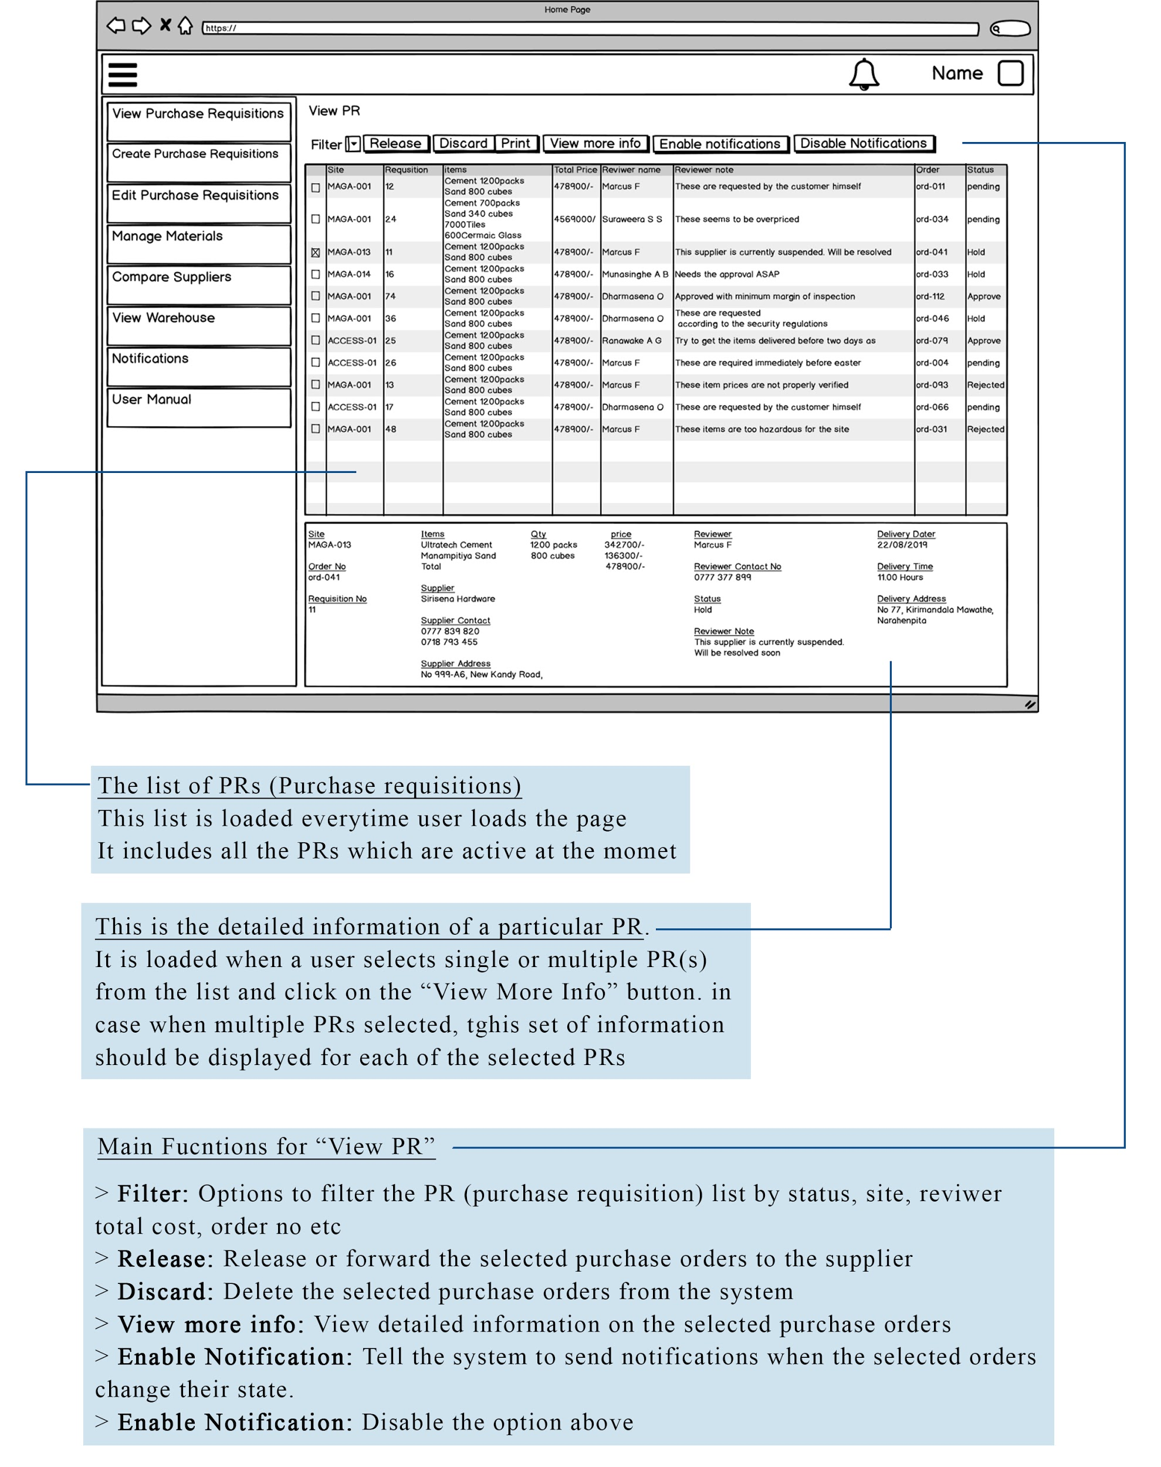

## Approve Purchase Requisition Page

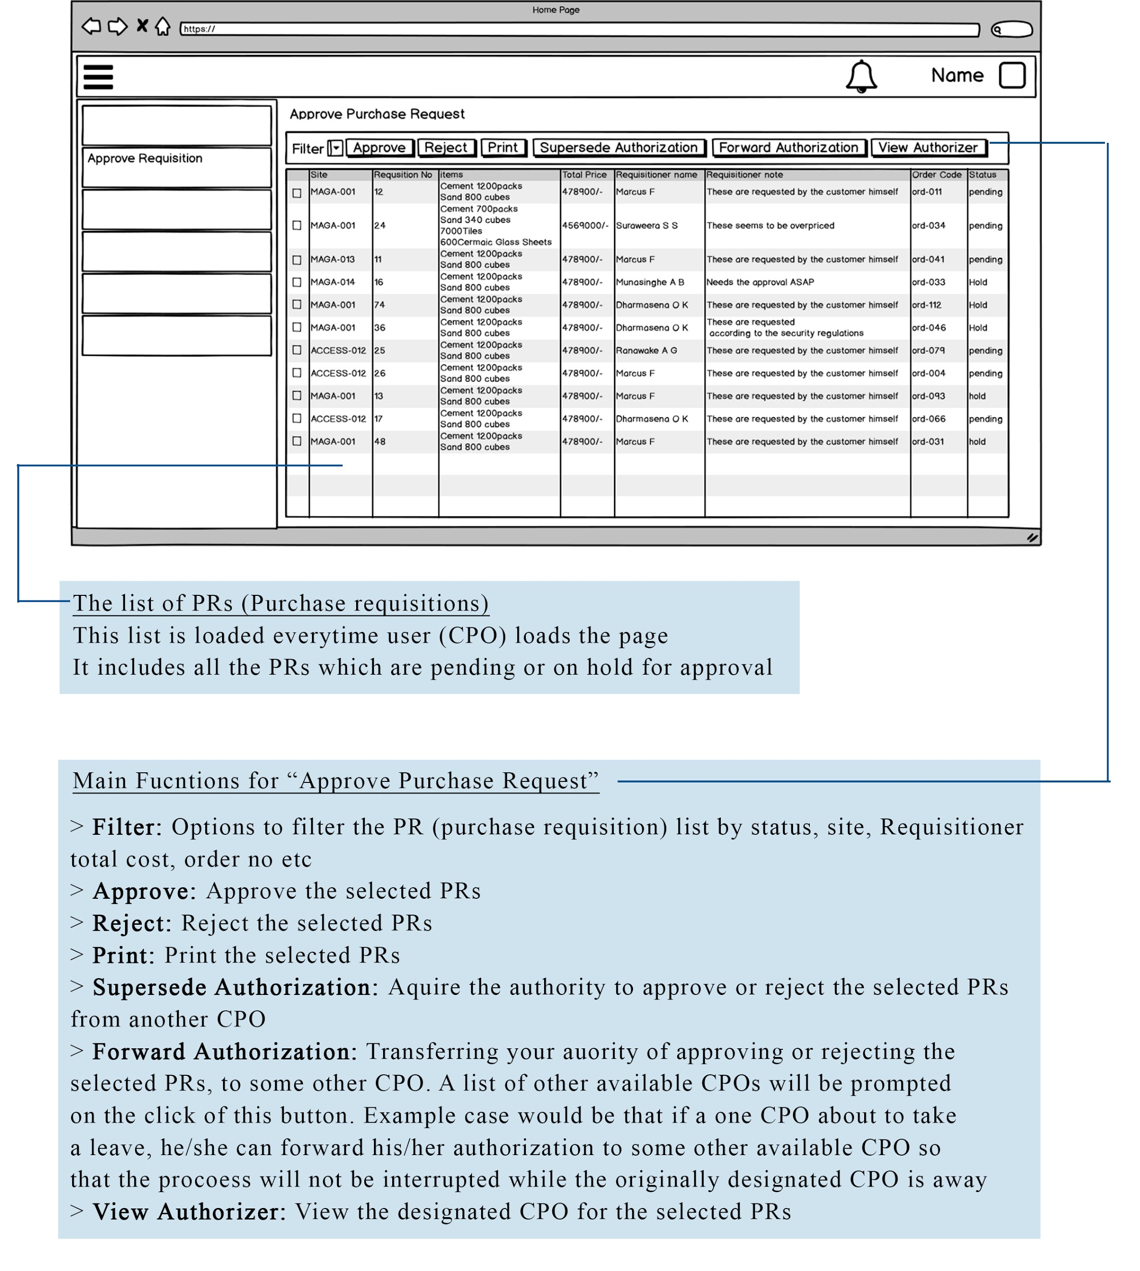

## Receive Orders Page

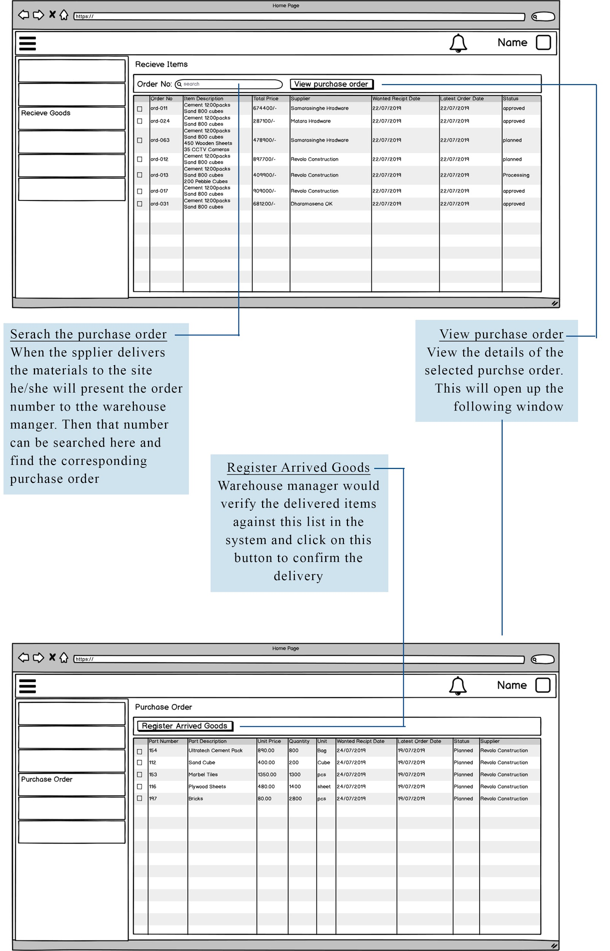

## View Purchase Requisitions UI for Mobile application

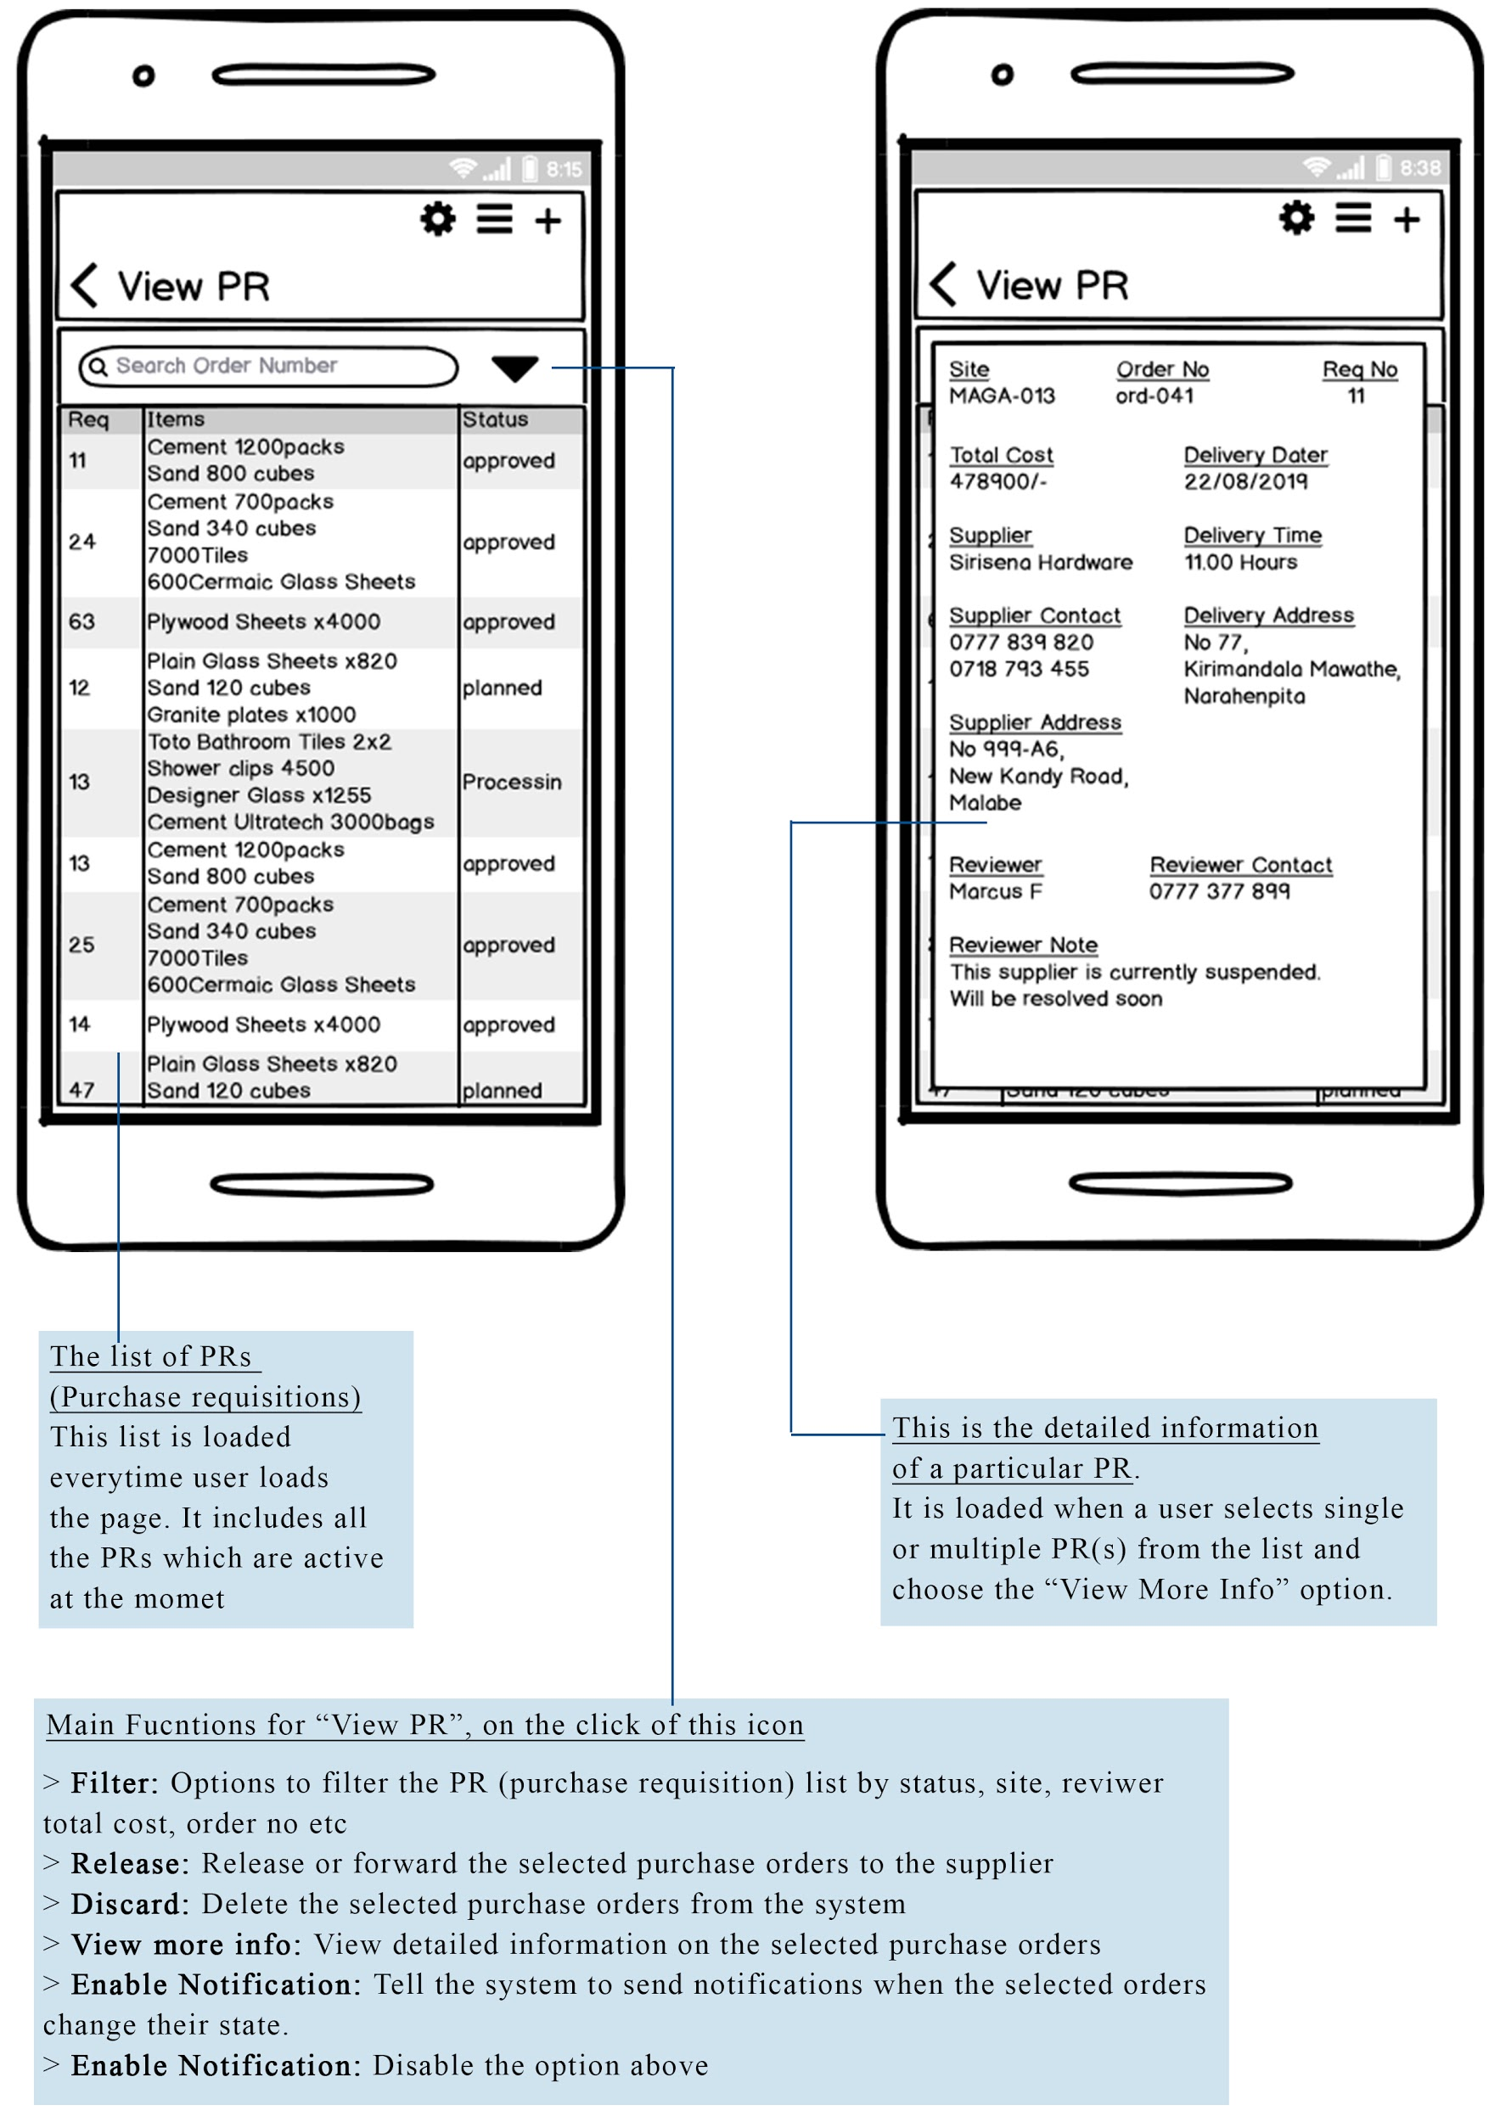

## Receive Orders UI for Mobile Application

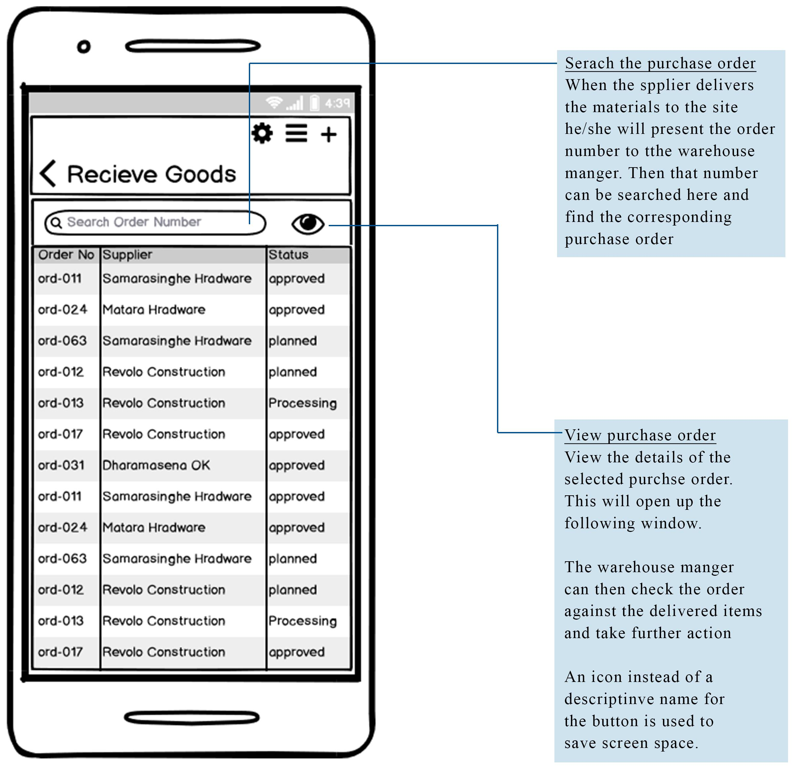

# **High fidelity User Interaction Diagrams**

## Login page for mobile application

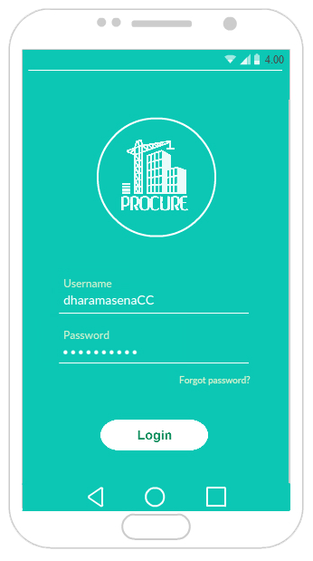

## Login page for web application

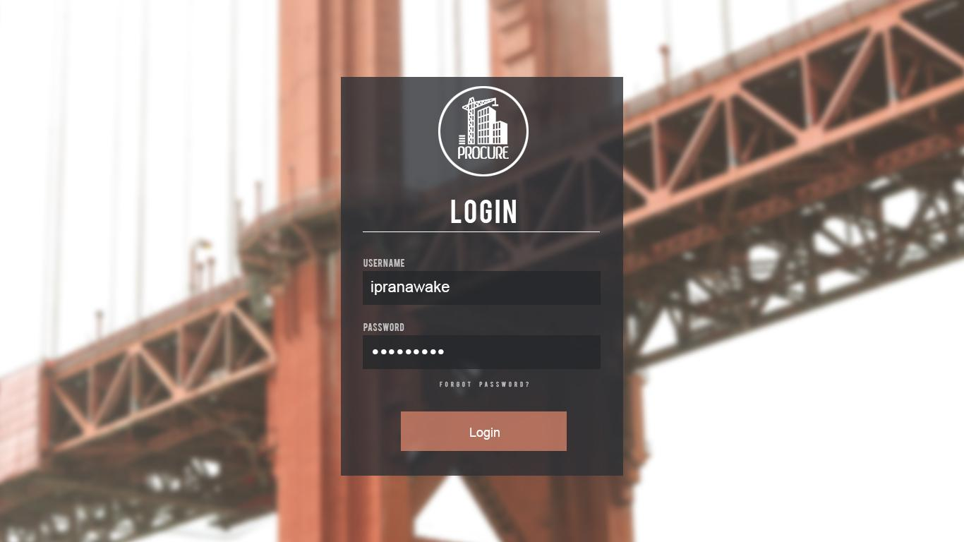

## Approve Purchase Requisition for Mobile Application

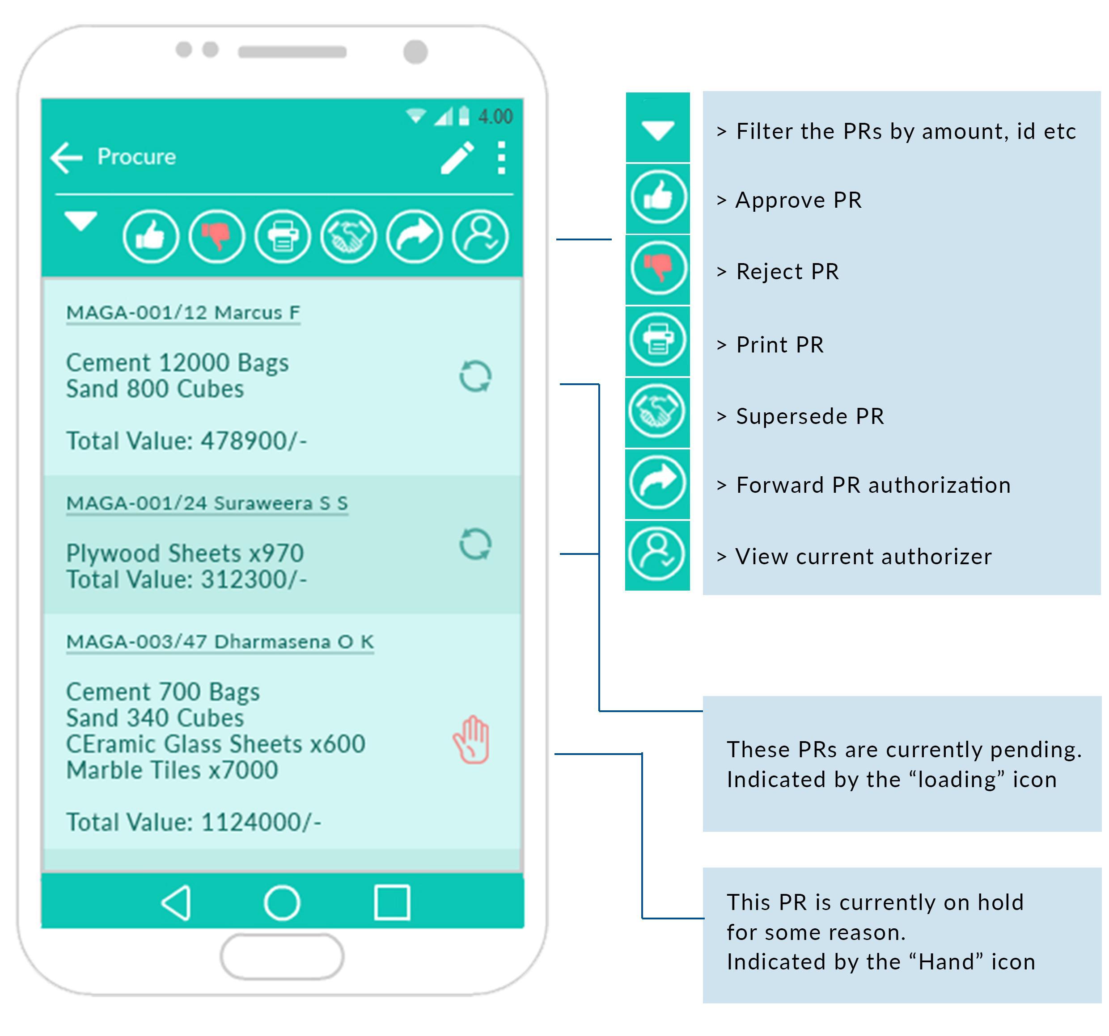

## Create Purchase Requisition for Mobile Application

